Diagonal Matrix Inversion Using Newton-Raphson Method

Here Newton-Raphson based method is used to calculate the inversion of diagonal matrix H because of its fast convergence and easy hardware implementation. The flow of the Newton-Raphson division are:

1. Compute the initial guess X0 for the reciprocal 1/H of the divisor H.
2. Compute iteratively more accurate guesses X1, X2,….., XS of the reciprocal.

To apply Newton’s technique to locate the reciprocal of H, it is necessary to obtain a function *f*(X) that has a root at X = 1/H

This function is shown in equation (1)



The solution using Newton-Raphson method is:

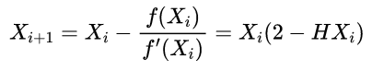

An approximate value of the initial guess X0 is formulated in (3). For 1 ≤ H < 2 (or 0.5 < X ≤ 1)



Error *ε* in the iteration *i* of Newton-Raphson is computed as



The error for the next iteration is calculated as:

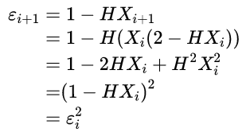

The squaring of the error at each iteration indicates the quadratic convergence of Newton-Raphson method. If the initial guess X0 of this method is chosen poorly then the convergence will be comparatively slow.

For log2_coder see here:

<https://en.wikibooks.org/wiki/A-level_Computing/AQA/Paper_2/Fundamentals_of_data_representation/Floating_point_numbers>